SCREEN SENSE – KID’S SCREENTIME VISUALIZATION

REPORT BY
PRABAKARAN N

1.OBJECTIVE

In This week 02, my main focus was on preprocessing the dataset and creating new features to make the data ready for analysis. I handled missing values and standardized inconsistent categories to ensure the data is clean and reliable. I also derived new columns such as age groups, screen time levels, device categories, and educational vs recreational ratios to help uncover meaningful patterns. Additionally, I formatted any date or time fields and saved the pre-processed dataset for future analysis. Overall, my goal was to prepare a well-structured dataset that is ready for deeper analysis and visualization in the upcoming weeks.

2.PREPROCESSING AND FEATURE ENGINEERING

2.1 Identifying and Handling Missing Data
Step 01:
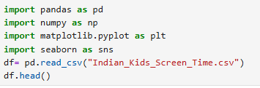
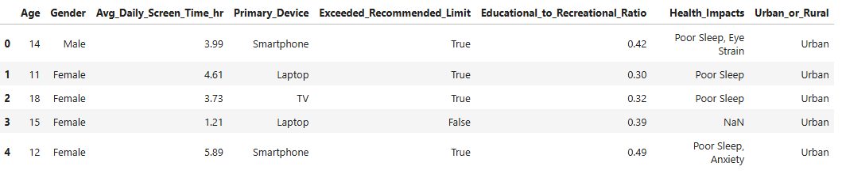
Output:
- To load the dataset and preview the first few rows to understand its structure and contents.
Step 02:
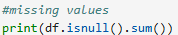
Output:
- Most columns are complete with no missing values, making them ready for analysis.
- The Health Impacts column has 3218 missing values, indicating that many entries do not have reported health effects.

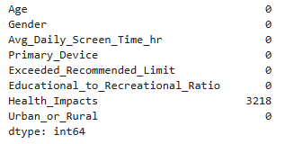

Step 03:
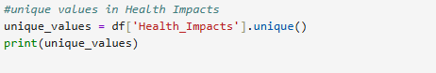
Output:
- To identify all distinct health issues reported in the Health Impacts column.
- The output lists all unique entries, like below

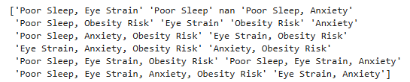
Step 04:
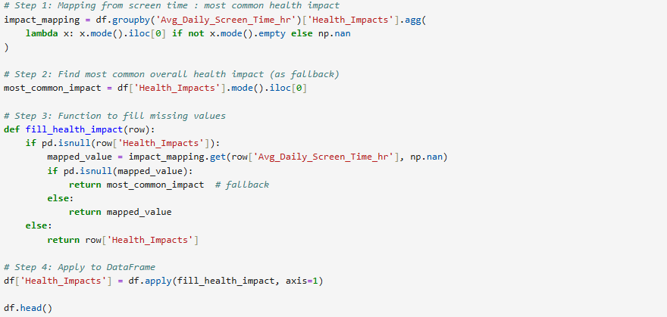
Output:
- To fill missing values in the Health Impacts column by mapping each child’s screen time to the most common health impact for that average screen time column.
- If no specific mapping exists, a fallback to the most common overall health impact is applied.

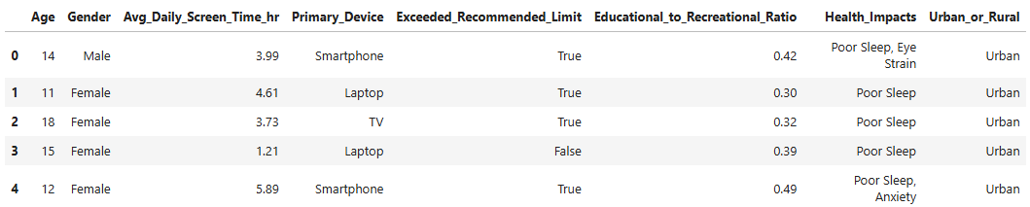
Step 05:
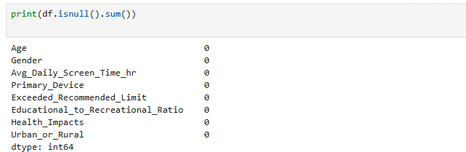 o

Output:
- To verify that all missing values in the Health Impacts column have been successfully filled.
Step 06:
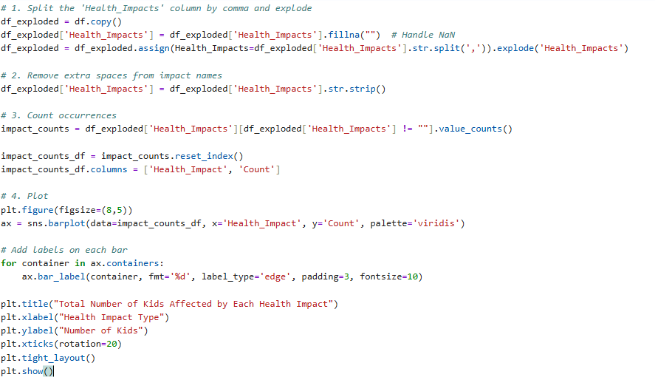

Output:
- To analyze the frequency of each health impact by splitting multiple impacts listed in one row and counting them individually.
- This helps understand which health issues are most common among children based on their screen time.

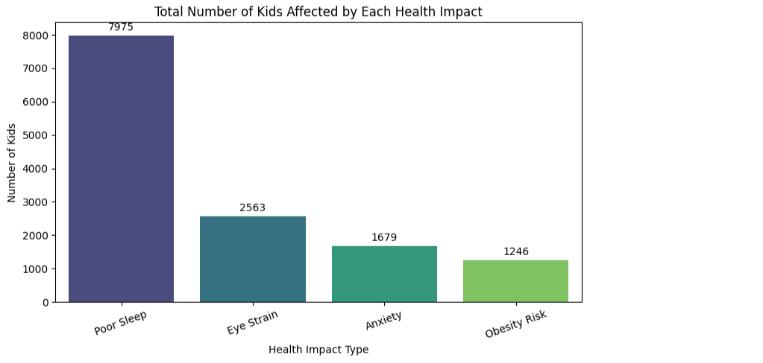
Step 07:

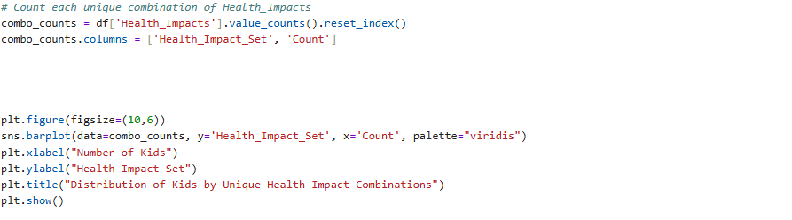

Output:
- To analyze the frequency of unique combinations of health impacts reported by children, instead of individual impacts.
- This helps identify which specific sets of health issues occur together most often.

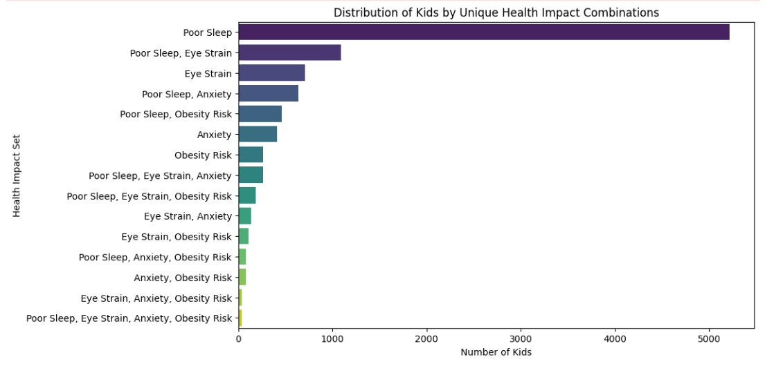

2.2 Harmonizing Categorical Values
Step 01:
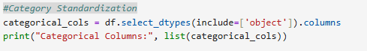
Output:
- To identify all categorical columns in the dataset that may require standardization
- The categorical columns identified are: Gender, Primary Device, Health Impacts, and Urban or Rural.

Step 02:
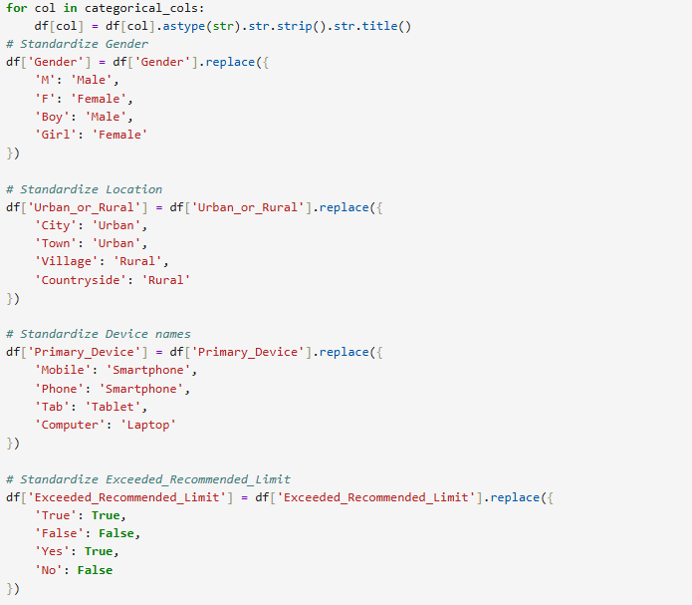

Output:
- To standardize categorical columns and ensure consistency across the dataset, which is essential for accurate analysis and visualization.

Step 03
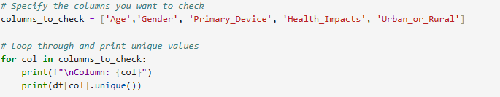
Output:
- To examine the unique values in selected columns and verify that categorical standardization has been applied correctly.
- The code displays unique values for Age, Gender, Primary Device, Health Impacts, and Urban or Rural.

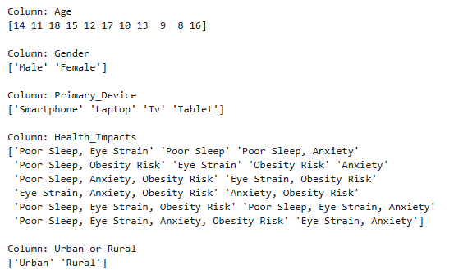

2.3 Feature Engineering: Derived Columns for Insights
Step 1:
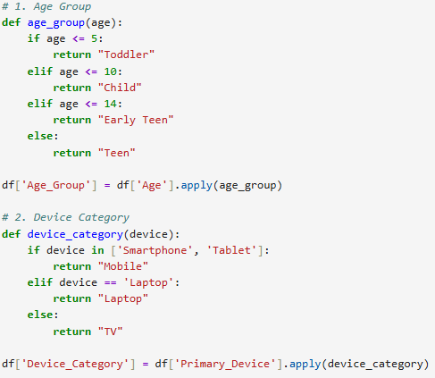
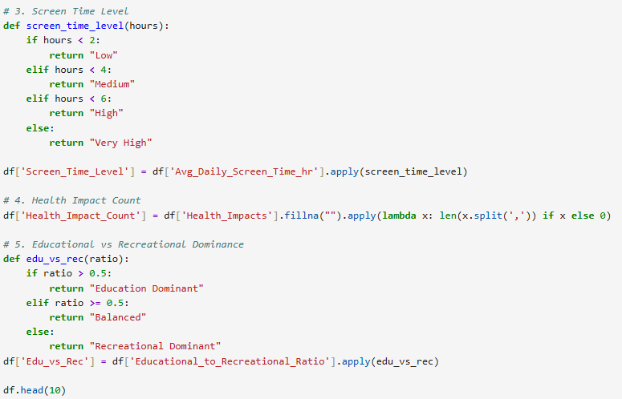
Output:
- To create new derived columns that provide more meaningful insights and enable easier analysis.
- These features include age groups, device categories, screen time levels, health impact counts, and educational vs recreational dominance.
- Age Group: Categorizes children into Toddler, Child, Early Teen, and Teen based on age.
- Device Category: Groups devices into Mobile, Laptop, or TV.
- Screen Time Level: Classifies average daily screen time as Low, Medium, High, or Very High.
- Health Impact Count: Counts the number of health impacts reported per child.
- Edu vs Rec: Indicates whether a child’s screen time is Education Dominant, Balanced, or Recreational Dominant.
- The first 10 rows confirm that all derived features are correctly calculated and added to the dataset, ready for further analysis or visualization.

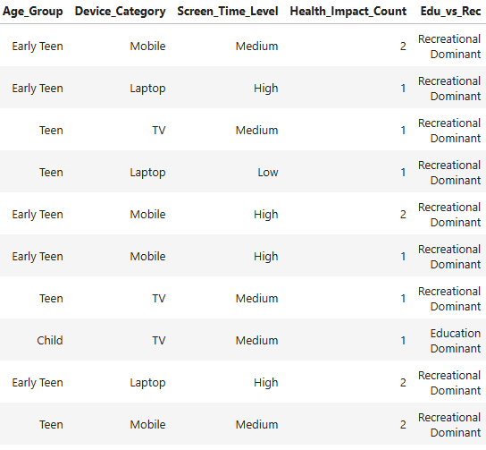
2.4 Exporting Preprocessed Data:
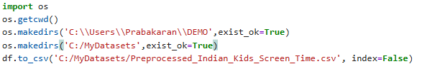
Output:
- To save the pre-processed dataset so it can be reused for analysis and visualization in future steps without repeating preprocessing.

3. CONCLUSION

In Week 2, I focused on preprocessing the dataset and performing feature engineering to make the data clean, consistent, and analysis-ready. I successfully handled missing values, standardized categorical fields, and created new derived columns such as age groups, device categories, screen time levels, health impact counts, and educational vs recreational ratios. These steps ensure that the dataset is structured, meaningful, and ready for further exploration and visualization.
By saving the pre-processed dataset and documenting the logic behind each transformation, I have created a reusable and reliable dataset that will support the upcoming analysis in future weeks. Overall, this week laid a strong foundation for deriving actionable insights from the data.

